Lecture Notes

<https://embed.ted.com/talks/avi_rubin_all_your_devices_can_be_hacked>

Assigments

Who Am I?

This section is just to introduce yourself to your classmates and your instructor.

****TASK 1:****

* Use ****YouTube**** to shoot a video about yourself of no more than 60 seconds. Be creative and look professional.
* In your introductory video, you should clearly state the following:
  + Your full name
  + Freshman, Junior, Sophomore, or Senior?
  + Your working status (fulltime/part-time)? If working, what type of work and where
  + Why are you interested in taking this course?
  + Your current experience with computer security (if any)
  + Where do you see yourself in the next five years?
* Please see samples [here](https://youtu.be/re5PMoMcPLE)and [here](https://www.youtube.com/watch?v=XdAM1Zymr48&feature=youtu.be)
* Post the Video in this discussion forum ****before the end of the second week of the semester****.

****TASK 2: (optional)****

* Create your ****Linkedin profile****(if you don't already have one) and ****invite**** all your classmates.
  + Make sure that your profile confirms according to the checklist found [here](https://university.linkedin.com/content/dam/university/global/en_US/site/pdf/LinkedIn Profile Checklist - College Students.pdf" \t "https://metrostate.learn.minnstate.edu/d2l/le/content/5375067/_blank)
  + You may want to look at the other Linkedin page [here](https://university.linkedin.com/linkedin-for-students" \t "https://metrostate.learn.minnstate.edu/d2l/le/content/5375067/_blank)to learn how to network and look for jobs and internships.

Points will be awarded ****only**** for entries that are submitted ****before the end of the second week of the semester.****

Blog It..?

Create a blog to document your learning experiences as you study Computer Security throughout the semester.

* ****TASK:**** Visit one of the many sites that offer free blogs, such as http://www.blogger.com, http://www.wordpress.com, or http://www.tumblr.com. Follow the site’s instructions to establish your own blog and give it a professional name. Make sure that the blog is publicly accessible by anyone. Please look [here](https://hervangshoua.wordpress.com/2015/09/04/what-is-a-computer-virus/) and [here](http://aabitblog.blogspot.com/) for samples
* ****TASK:**** For the purpose of this class, your blog will be a place to note/discuss/comments on websites that you find useful or interesting related to the general field of computer-security. Please provide a brief synopsis of the website. On a ****weekly basis****, report ****at**** ****least one**** site that contain useful resources/information related to the general topic of computer security ****OR**** post an interesting article in the same area. If you read an article or come across an interesting post elsewhere that is related to cybersecurity, please post it here for the benefit of rest of the class.
* ****TASK:**** Under the “Blog it” discussion forum, create a separate thread under your blog name. Keep your thread up to date by posting links to your weekly blog entries, under your own thread.
* ****TASK:**** On a weekly basis, you are supposed to ****read and discuss at least 5**** ****blogging entries**** posted by your fellow students, raise questions, and/or make comments. You will not get the discussion points if you don’t perform this task

****Full points**** will be awarded ****only****, if you post links to your blog entries and provide comments to other entries before the ****end of each week****, throughout the semester.

Sample post to D2L:

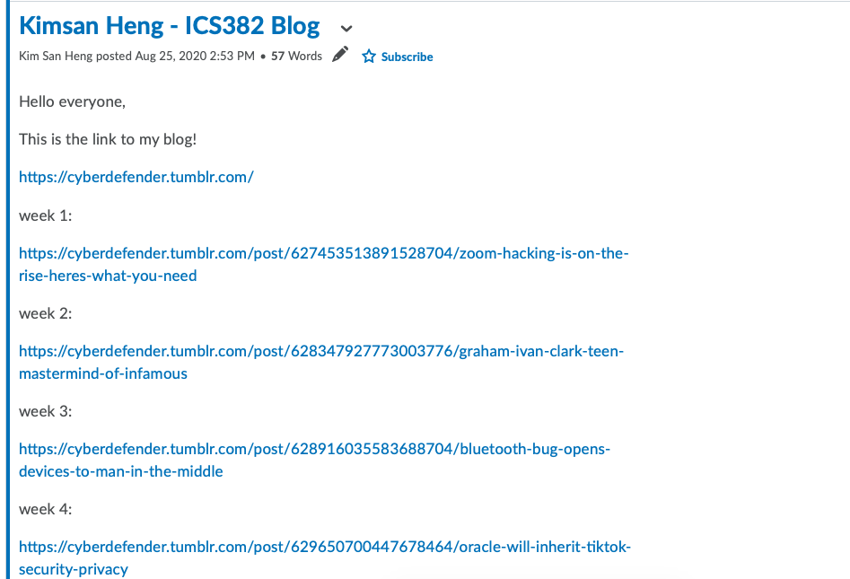

Lab #1

Please complete the cloud Lab and submit all the required work (assessment sheet, snapshots, etc.) via the dropbox.

****Please include more screenshots in addition to the required ones.****

****All the screenshots must show the system clock of the virtual environment.****

****Please submit only PDF file type.****